**PROJECT REPORT ON**

***ONLINE MUSIC STORE***

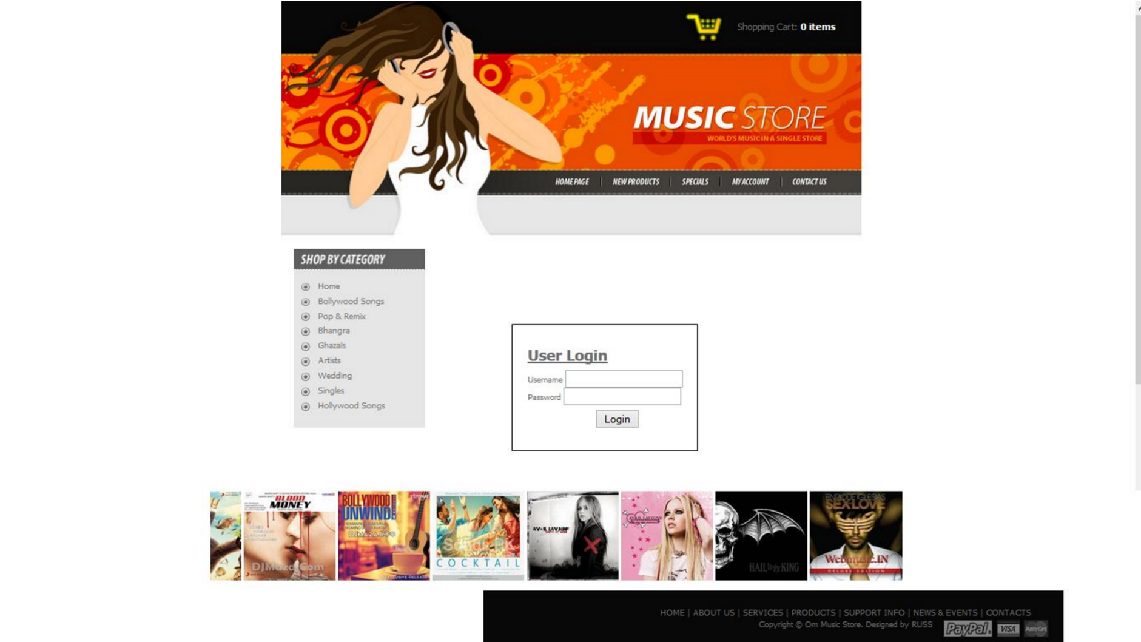

SUBMITTED BY

* SHIVAM RAJ
* SHAMIR KUMAR
* RITURAJ
* UTTAM KUMAR

**ACKNOWLEDGEMENT**

The satisfaction that accompanies the successful completion of any task would be incomplete without the mention of people whose ceaseless cooperation made it possible, whose constant guidance and encouragement crown all efforts with success.

We are grateful to our project mentor, for his guidance, inspiration and constructive suggestions that helped us in the preparation of this project. I will like to give a special mention to my colleagues. Last but not the least I am grateful to all the faculty members of ORIENS INFOTECH

PVT. LTD for their support.

**ABSTRACT**

The main aim of creating this Online Music Store System Java based web application is to provide user friendly tool for music web sites. This is one type of online shopping for music files.

Most of the websites now a day’s selling their products through online but download music files with free of cost makes problem with piracy so this is the best place to stop music piracy over the internet. Here the customer should login through Music store website and buy selected music files like songs, movies, and private albums by using papal, credit card option. Once the payment has done then selected music files can be downloaded directly to the local system of the customer. The main advantage is it is user friendly, provide us 24 hours customer service, and decrease the manual efforts and Time.

**TABLE OF CONTENT**

TOPICS PAGE NO

1. Introduction 6

2. Methodology used to develop the project 7-12

3. System specification 13

4. System design 14-16

* 1. 0-level DFD 14
  2. 1-level DFD 15
  3. ERD 16

5. Table structure 17-18

6. Snapshots of the screen 19-38

7. Future scope & Limitation 39

8. Conclusion 40

9*.* Bibliography 41

**INTRODUCTION**

1.1 OVERVIEW OF THE PROJECT:

1*.* USERS’ AREA:

* User doesn’t have to sign up here first. As a viewer, anyone can see the Public website. Only being a member of the website, they can access their own account, and download music.

The total facility that a user gets is listed below:

* Create their Profile.
* Next time for entering to profile they have to enter the same ID and Password.
* User can search and download the Specific music as well as the
* Album and details, being a member of this Music Gallery group. But anyone can access the website and listen Songs, yet they are not members.

1.2. Objective of Music gallery:

* Users can register & search for any kind of music which they are needed.
* \ Over all, the underlying purpose of this project is to help users by providing best music and Entertainment easily, by a web based application like “Online Music Store”, using J2EE.

**METHODOLOGY USED TO DEVELOP THIS PROJECT**

**J2EE** is basically used to develop this project. The abbreviation of j2ee is JAVA 2 PLATFORM ENTERPRISE EDITION. It is platform independent, java centric environment from Sun Microsystem (together with industry partners such as IBM) for developing, building and deploying Web based enterprise applications online. The j2ee platform consists of a set of services, APIs and PROTOCOLS that provide the functionality for developing multitier, Web based applications. J2ee simplifies application development and decreases the need for programming and programmer training by creating standardized, reusable modular components and by enabling the tier to handle many aspects of programming automatically.

Some of the key features and services of j2ee

* At the client tier, j2ee supports pure HTML, as well as Java applets or applications. It relies on Java Server Pages and servlet code to create HTML or other formatted data for the client.
* Enterprise JavaBeans (EJBs) provide another layer where the platform’s logic is stored. An EJB server provides functions

Such as threading, concurrency, security, and memory management. These services are transparent to the author.

* Java Database Connectivity (JDBC) which is the java equivalent to Open Database Connectivity (ODBC), is the standard interface for java databases.
* The java servlet API enhances consistency for developers without requiring a graphical user interface.
* The Java Development Kit (JDK) is included as the core language package
* Write Once Run Anywhere technology is included to ensure portability.
* A security model is included to protect data both locally and in web based applications.

J2EE also includes a number of components added to J2SE model, such as the following:

* Full support is included for Enterprise JavaBeans. EJB is a server-based technology for delivery of program components in an enterprise environment. It supports the Extensible Mark-up language (XML) and has enhanced deployment and security features.
* The Java servlet API (Application Programming Interface) enhances consistency for developers without requiring a graphical user interface (GUI).
* Java Server pages (JSP) is the java equivalent to Microsoft’s Active Server Pages (ASP) and is used for dynamic Web-enables data access and manipulation.

The J2EE architecture consists of four major elements:

* The J2EE Application programming model is standard programming model used to facilitate the development of multi-tier, thin client applications.
* The J2EE Platform includes necessary policies and APIs such as the Java servlets as Java Message Services (JMS).
* The J2EE compatibility test suite ensures that J2EE products are compatible with the platform standards.
* The J2EE reference implementation explains J2EE capabilities and provides its operational definitions.

**JAVA SERVER PAGES (JSP)** is a technology that helps software developers create dynamically generated web pages based on HTML, XML or other document types. Released in 1999 by Sun Microsystems JSP is similar to PHP, but it uses the Java programming language.

To deploy and run Java Server pages, a compatible web server with a servlet container, such as Apache Tomcat or Jetty, is required.

Architecturally JSP may be viewed as a high-level abstraction of Java Servlets. JSPs are translated into servlets at runtime, each JSP servlet is cached and re-used until the original JSP is modified. JSP can be independently or as the view component of a server side model-view-controller design, normally with JavaBeans as the model and Java Servlets (or a framework such as Apache Struts) as the controller. This is a type of Model 2 architecture.

JSP allows Java code and certain pre-defined actions to be interleaved with static web mark-up content, either the resulting page being compiled and executed on the server to deliver document. The compiled pages, as well as any dependent

Java libraries, use Java byte code rather than a native

software format. Like any other java program, they must be executed within a Java virtual machine (JVM) that integrates with the server’s host operating system to provide an abstract platform-neutral environment.

JSP are usually used to deliver HTML and XML documents, but through the use of output stream, they can deliver other types of data as well. The Web container creates JSP implicit object like page Context, serveletContext, session, request & response.

Now public interest **Servlet** defines methods that all servlets must implement. A servlet is a small java program that runs within a Web server. Servlets receive and respond to requests from Web clients, usually across HTTP, the hyper text transfer protocol.

To implement this interface you can write a generic servlet that extends javax.servlet.GenericServlet or an HTTP servlet that extends javax.servlet.http.httpServlet. This interface defines methods to initialize a servlet, to service request, and to remove servlet from server. These are known as life cycle methods and are called in the following sequences: The servlet is constructed, then initialized with the init method.

1. Any calls from the clients to the service method are handled.
2. The servlet is taken out of service, then destroyed with the destroy method, then garbage collected and finalized.

In addition to the life cycle methods, this interface provides the getServletConfig method, which the servlet can use to get any start up information and the GetServletInfo method, which allows the servlet to return basic information about itself, such as author, version and copyright.

**Oracle Database** (commonly referred to as oracle RDBMS or simply Oracle) is an object-relational database management system produced and marketed by Oracle Corporation.

Larry Ellison and two friends and former co-workers, Bob Miner and Ed Oates. Started a consultancy called Software development Laboratories (SDL) in 1977. SDL developed the original version of the oracle software. The name Oracle comes from the code name of a CIA funded project Ellison had worked on while previously employed by Ampex. If the oracle database administrator has implemented oracle RAC (Real Application Clusters), then multiple instances, usually on different servers, attach to a central storage array. This scenario offers advantages such as better performance, scalability and redundancy. However, support becomes more complex and many sites do not use RAC. In version 10g grid computing introduced shared resources where an instance can use (for example) CPU resources from another node (computer) in the grid. The oracle DBMS can store and execute stored procedures and functions within itself. PL/SQL (Oracle Corporation’s proprietary extension to SQL) or the object oriented language Java can invoke such code objects and/or provide the programming structures for writing them.

**Apache Tomcat** is an open source web server and servlet container developed by the Apache Software Foundation (ASF). Tomcat implements several Java EE specifications for Java code to run in.

Apache is developed and maintained by an open community of developers under the auspices of the Apache Software Foundation, released under the Apache License 2.0 license, and is open-source software.

Tomcat 7.x implements the Servlet 3.0 and JSP 2.2 specifications. It requires Java version 1.6, although previous versions have run on Java 1.1 through 1.5. Version 5 through 6 saw improvements in garbage collection, JSP parsing, performance and scalability. Native wrappers,

known as “Tomcat Native”, are available for Microsoft Windows and Unix for platform integration.

**HARDWARE & SOFTWARE SPECIFICATIONS**

**HARDWARE PECIFICATIONS FOR SERVER:**

Computer :- PC, Laptop

Processor :- Intel Pentium dual core

RAM :- 2GB

Input Device :- Mouse, keyboard

Output Device :- Printer, monitor

**SOFTWARE SPECIFICATIONS FOR SERVER:**

OPERATING SYSTEM : windows 7 and above

APPLICATION SOFTWARE : Eclipse, JDK 1.7.

SERVER : Apache tomcat 7.0

DATABASE : Oracle database 10g

TECHNOLOGY : J2EE

**SOFTWARE SPECIFICATION FOR CLIENT:**

Browsers like internet explorer, google chrome, Mozilla Firefox.

**SYSTEM DESIGN**

***DATA FLOW DIAGRAM***

*4.1 0 LEVEL DFD*

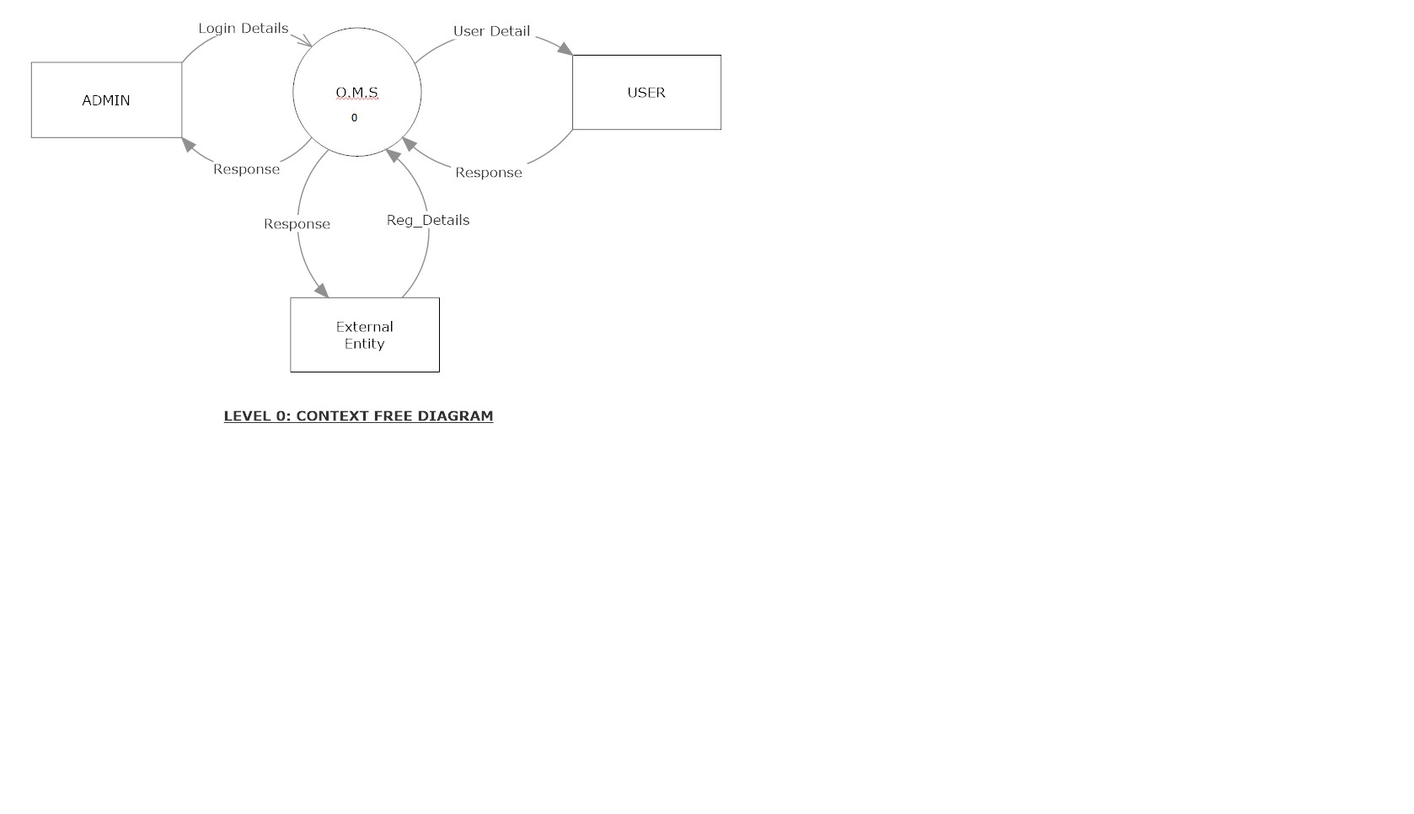

4.1

1

-

LEVEL DFD

:

-

USER

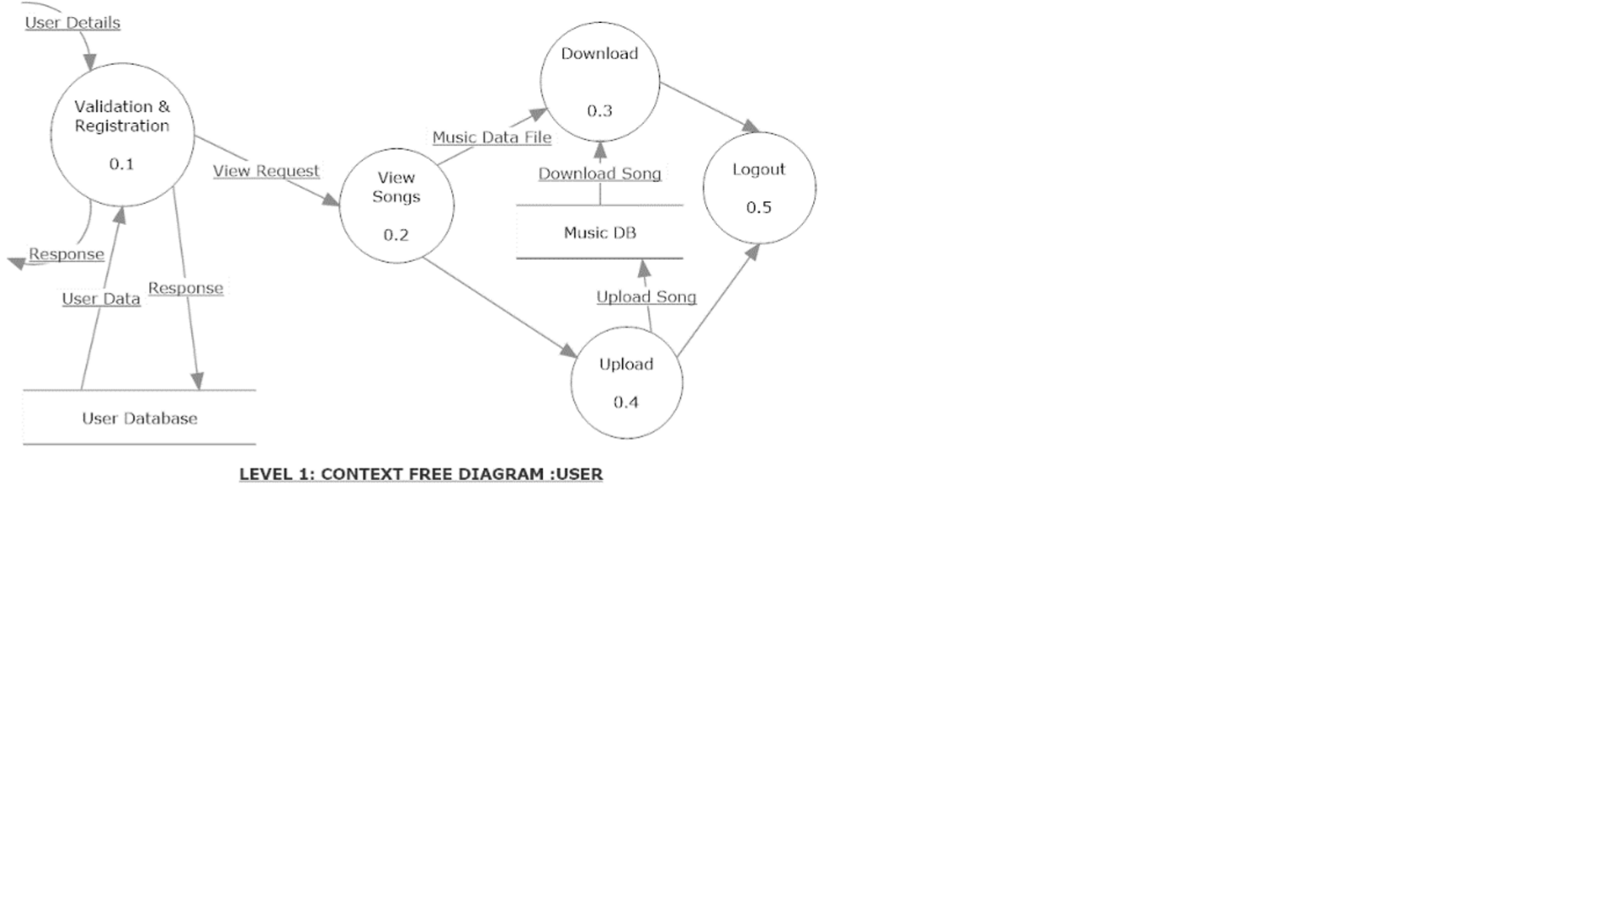

# 4.2 LELEL 1 DFD: - ADMIN

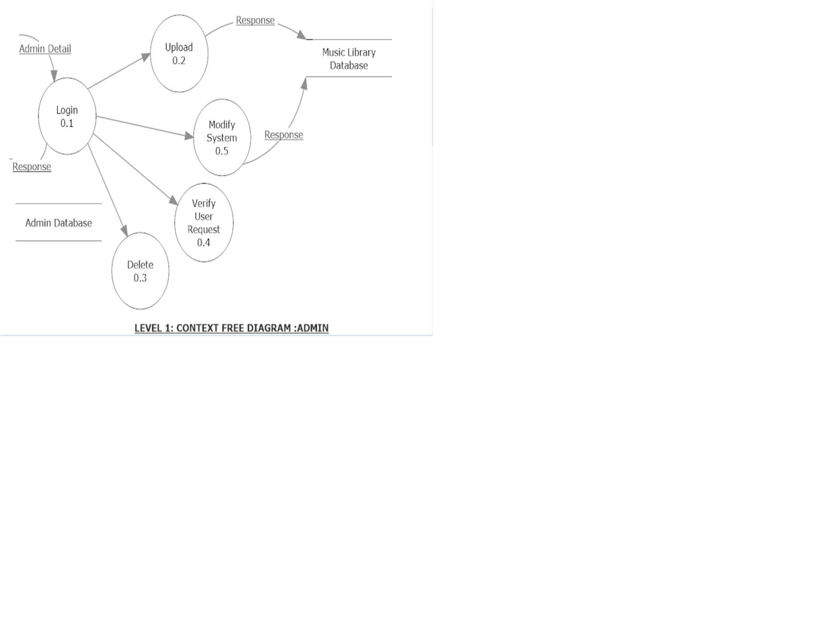

4.2 ERD

Since, there exists no relationships between the tables. So, no erd can be drawn.

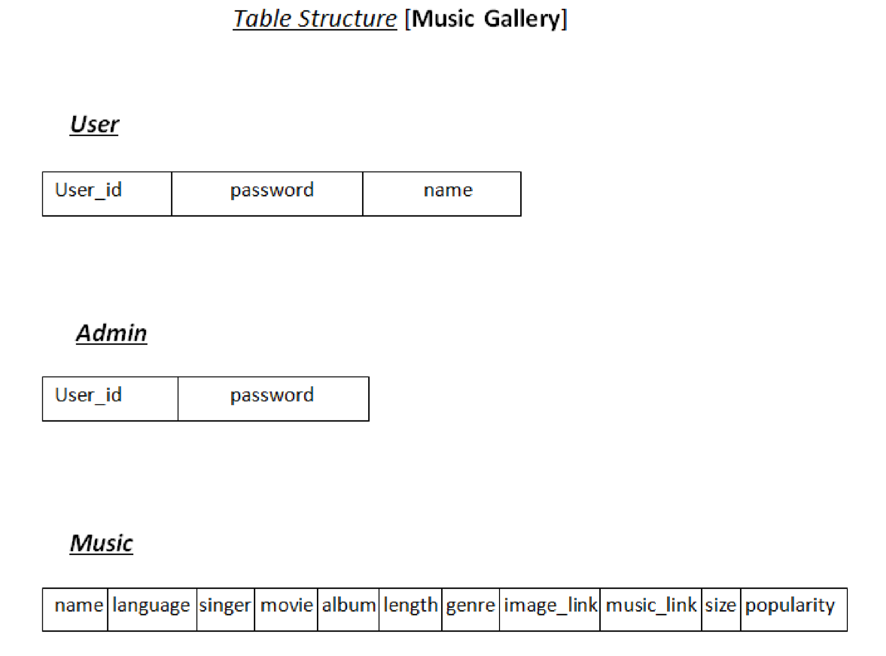

4.3 USE CASE DIAGRAM

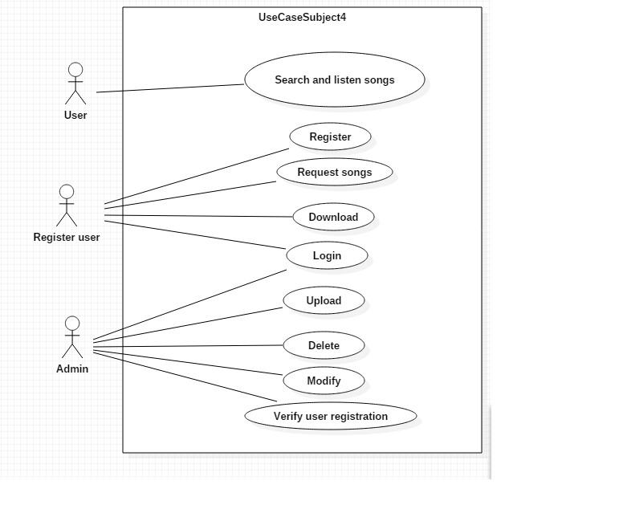

**TABLE STRUCTURE**

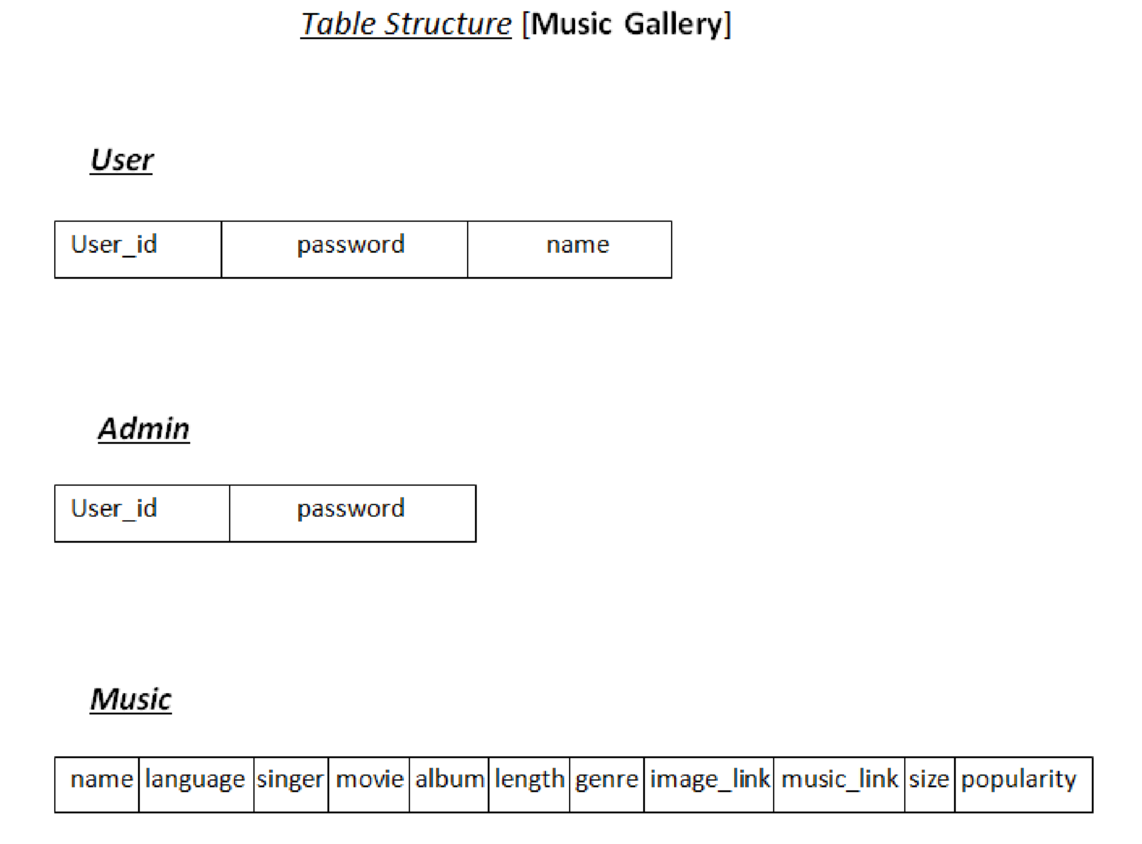

**TABLE : 1 USER DATABASE**

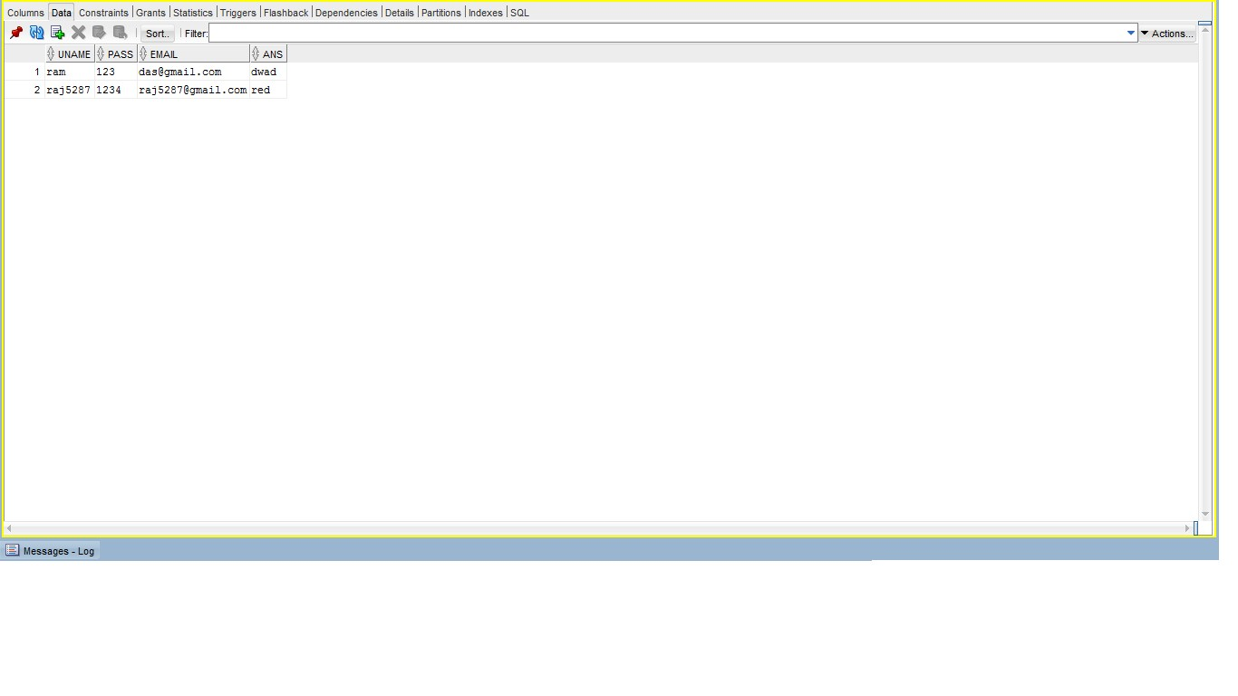

**TABLE 2:- ADMIN DATABASE**

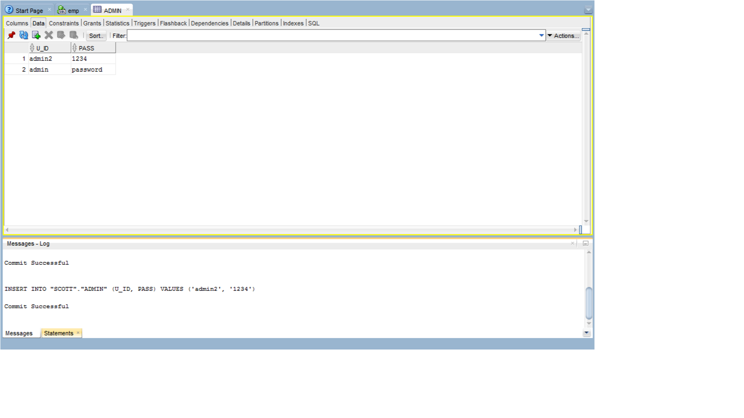

**TABLE 3:- MUSIC DATABASE**

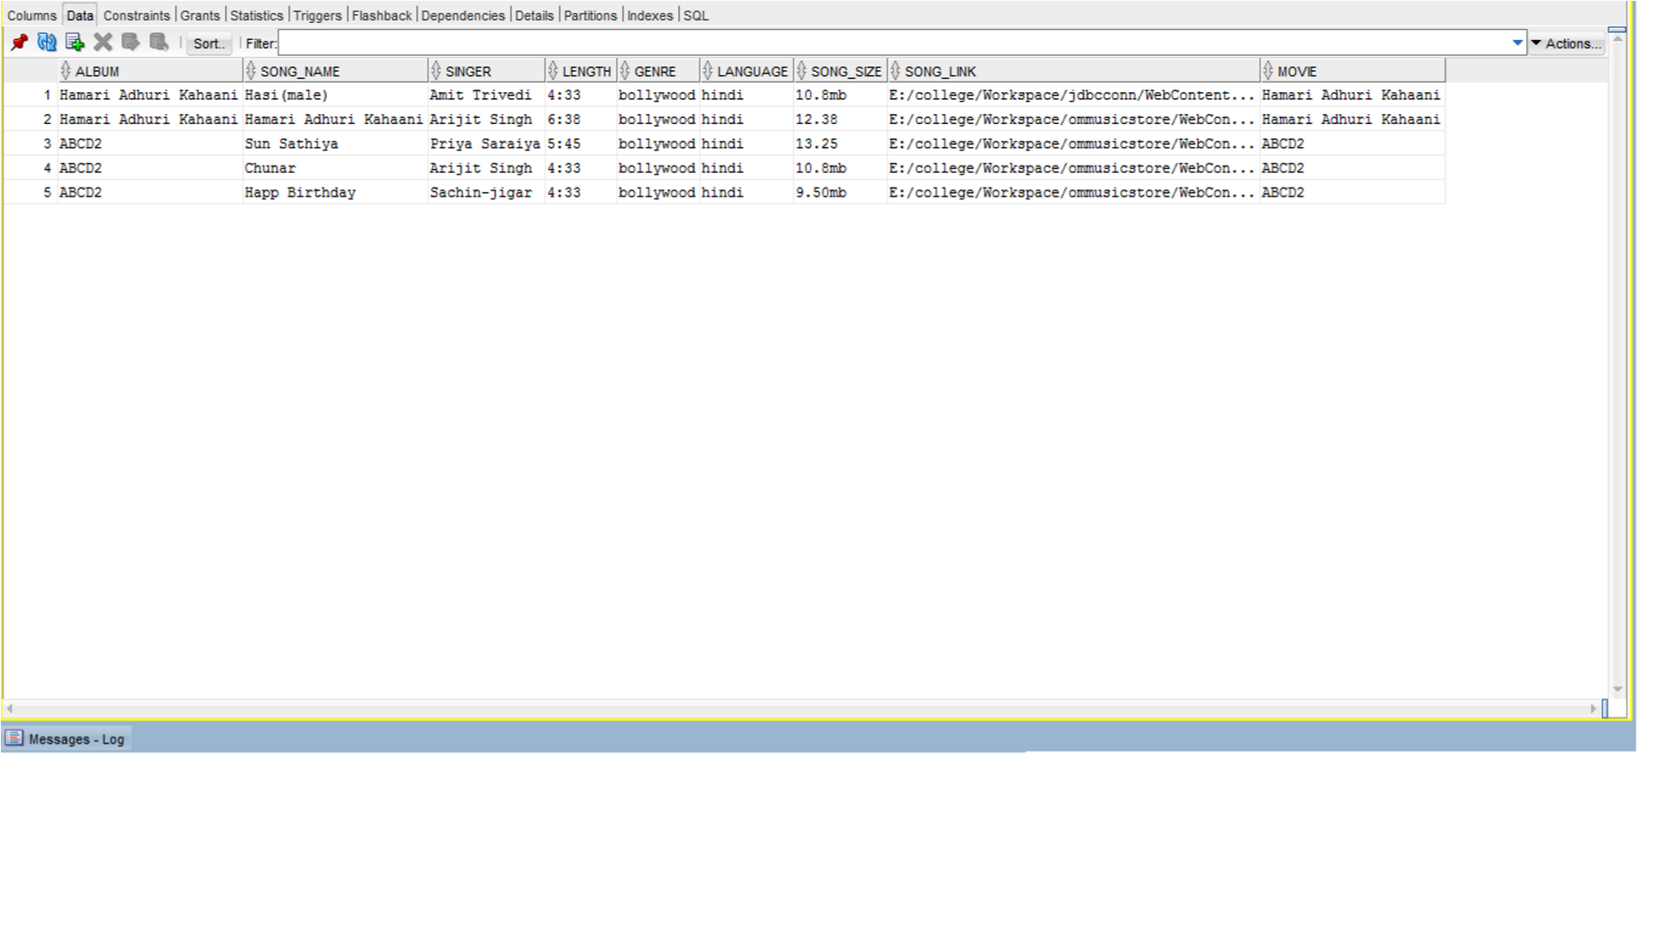

**SNAPSHOTS OF THE SCREEN**

**HOME PAGE:-**

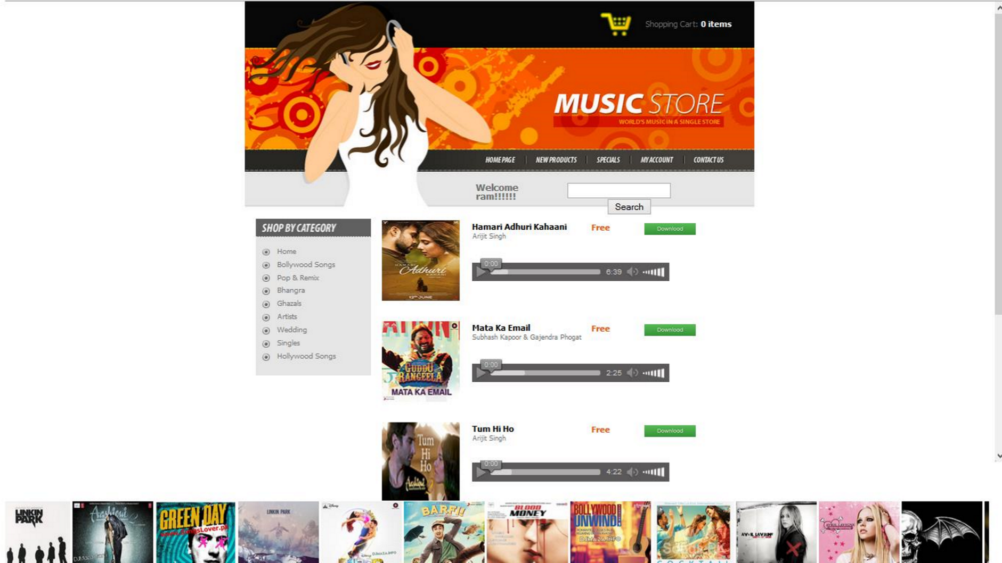

**CODE (Homepage)**

<!DOCTYPE html PUBLIC "-//W3C//DTD XHTML 1.0 Transitional//EN" "http://www.w3.org/TR/xhtml1/DTD/xhtml1-transitional.dtd">

<html xmlns=*"http://www.w3.org/1999/xhtml"*><head>

<meta http-equiv=*"Content-Type"* content=*"text/html; charset=utf-8"* /><title>Music Store</title>

<link href=*"css/styles.css"* rel=*"stylesheet"* type=*"text/css"* />

</head>

<body>

<div id=*"header"*>

<div id=*"logo"*><a href=*"#"*><img src=*"images/logo.jpg"* title=*"Music Store"* alt=*"Music Store"* border=*"0"* height=*"55"* width=*"262"* /></a></div>

<ul class=*"cart"*>

<li><span>Shopping Cart:</span> 0 items</li>

</ul>

<ul class=*"lang"*>

<li>

<a href=*"admin_login.html"*><img src=*"images/btn_admin.png"* width=*"100"* height=*"25"* alt=*""*/></a> </li>

</ul>

<ul class=*"currency"*>

<li class=*"uimag"*>

<a href=*"user_login.html"*><img src=*"images/btn_userlog.jpg"* width=*"100"* height=*"25"* alt=*""*/> </a>

</li>

<li class=*"fbimage"*>

<a href=*"facebook.com"*><img src=*"images/btn_fb.jpg"* width=*"30"* height=*"25"* alt=*""*/></a>

</li>

<li class=*"twimage"*>

<a href=*"#"*><img src=*"images/btn_tw.jpg"* width=*"30"* height=*"25"* alt=*""*/></a>

</li>

</ul>

<ul class=*"menu"*>

<li class=*"home"*><a href=*"index.html"* title=*"Home Page"*>Home</a></li>

<li class=*"line"*></li>

<li class=*"new"*><a href=*"#"* title=*"New Products"*>New</a></li>

<li class=*"line"*></li>

<li class=*"specials"*><a href=*"#"* title=*"Specials"*>specials</a></li>

<li class=*"line"*></li>

<li class=*"account"*><a href=*"#"* title=*"My Account"*>Account</a></li>

<li class=*"line"*></li>

<li class=*"contact"*><a href=*"#"* title=*"Contact Us"*>Contacts</a></li>

</ul>

</div>

<div id=*"content"*>

<div id=*"leftPan"*>

<div id=*"categories"*>

<h2></h2>

<ul>

<li><a href=*"index.html"*>Home</a></li>

<li><a href=*"reg.html"*>Bollywood Songs</a></li>

<li><a href=*"reg.html"*>Pop & Remix</a></li>

<li><a href=*"reg.html"*>Bhangra</a></li>

<li><a href=*"reg.html"*>Ghazals</a></li>

<li><a href=*"reg.html"*>Artists</a></li>

<li><a href=*"reg.html"*>Wedding</a></li>

<li><a href=*"reg.html"*>Singles</a></li>

<li><a href=*"reg.html"*>Hollywood Songs</a></li>

</ul>

</div>

</div>

<div id=*"middlePan"*>

<!-- PROD 1 -->

<div class=*"prod"*>

<div class=*"prodimg"*><a href=*"#"*><img src=*"images/HAK.jpg"* alt=*""* border=*"0"* height=*"123"* width=*"119"* /></a></div>

<div class=*"txt"*>

<p><a href=*"music/HAK.mp3"*>Hamari Adhuri Kahaani</a><br />

Arijit Singh<br />

<br />

</p>

</div>

<div class=*"price"*>

<p>Free</p>

</div>

<div class=*"imag"*>

<a href=*"music/HAK.mp3"*><img src=*"images/download.jpg"* width=*"78"* height=*"18"* alt=*""*/></a>

</div>

<div class=*"action"*>

<audio preload=*"none"* controls=*"controls"*>

<source src=*"music/HAK.mp3"* type=*"audio/mpeg"*>

</audio>

</div>

</div>

<!-- PROD 2 -->

<div class=*"prod"*>

<div class=*"prodimg"*><a href=*"#"*><img src=*"images/Mata_Ka_Email.jpg"* alt=*""* border=*"0"* height=*"123"* width=*"119"* /></a></div>

<div class=*"txt"*>

<p><a href=*"music/Mata_Ka_Email.mp3"*>Mata Ka Email</a><br />

Subhash Kapoor & Gajendra Phogat<br />

<br/>

</p>

</div>

<div class=*"price"*>

<p>Free</p>

</div>

<div class=*"imag"*>

<a href=*"music/Mata_Ka_Email.mp3"*><img src=*"images/download.jpg"* width=*"78"* height=*"18"* alt=*""*/></a>

</div>

<div class=*"action"*>

<audio preload=*"none"* controls=*"controls"*>

<source src=*"music/Mata_Ka_Email.mp3"* type=*"audio/mpeg"*>

</audio>

</div>

</div>

<!-- PROD 3 -->

<div class=*"prodlast"*>

<div class=*"prodimg"*><a href=*"#"*><img src=*"images/aashiqui2.jpg"* alt=*""* border=*"0"* height=*"123"* width=*"119"* /></a></div>

<div class=*"txt"*>

<p><a href=*"music/tum_hi_ho.mp3"*>Tum Hi Ho</a><br />

Arijit Singh<br />

<br/>

</p>

</div>

<div class=*"price"*>

<p>Free</p>

</div>

<div class=*"imag"*>

<a href=*"music/tum_hi_ho.mp3"*><img src=*"images/download.jpg"* width=*"78"* height=*"18"* alt=*""*/></a>

</div>

<div class=*"action"*>

<audio preload=*"none"* controls=*"controls"*>

<source src=*"music/tum_hi_ho.mp3"* type=*"audio/mpeg"*>

</audio>

</div>

</div>

</div>

<div class=*"clear"*></div>

</div>

<div class=*"mov_img"*>

<marquee onmouseover="stop();" onmouseout="start();">

<img src=*"image_links/CoverLP.jpg"* width=*"123"* height=*"119"* alt=*""*/>

<img src=*"image_links/A2.jpg"* width=*"123"* height=*"119"* alt=*""*/>

<img src=*"image_links/Covergd.jpg"* width=*"123"* height=*"119"* alt=*""*/>

<img src=*"image_links/CoverLPR.jpg"* width=*"123"* height=*"119"* alt=*""*/>

<img src=*"image_links/ABCD_2.jpg"* width=*"123"* height=*"119"* alt=*""*/>

<img src=*"image_links/Barfi.jpg"* width=*"123"* height=*"119"* alt=*""*/>

<img src=*"image_links/Bilal Seed.jpg"* width=*"123"* height=*"119"* alt=*""*/>

<img src=*"image_links/Blood Money.jpg"* width=*"123"* height=*"119"* alt=*""*/>

<img src=*"image_links/Bollywood_Unwind.jpg"* width=*"123"* height=*"119"* alt=*""*/>

<img src=*"image_links/Cocktail.jpg"* width=*"123"* height=*"119"* alt=*""*/>

<img src=*"image_links/Cover.jpg"* width=*"123"* height=*"119"* alt=*""*/>

<img src=*"image_links/Cover1.jpg"* width=*"123"* height=*"119"* alt=*""*/>

<img src=*"image_links/CoverAS.jpg"* width=*"123"* height=*"119"* alt=*""*/>

<img src=*"image_links/CoverSAL.jpg"* width=*"123"* height=*"119"* alt=*""*/>

</marquee>

</div>

<div id=*"footer"*>

<img src=*"images/cards.jpg"* alt=*""* height=*"20"* width=*"141"* />

Copyright © Om Music Store. Designed by <a href=*""*>RUSS</a><img src=*"images/btn_fbtw.jpg"* width=*"450"* height=*"112"* alt=*""*/></p>

<p><a href=*""*>Supported by </a><a href=*""* target=*"_blank"*>ommusicstore.com</a></p>

</div>

</body></html>

**USER LOGIN:-**

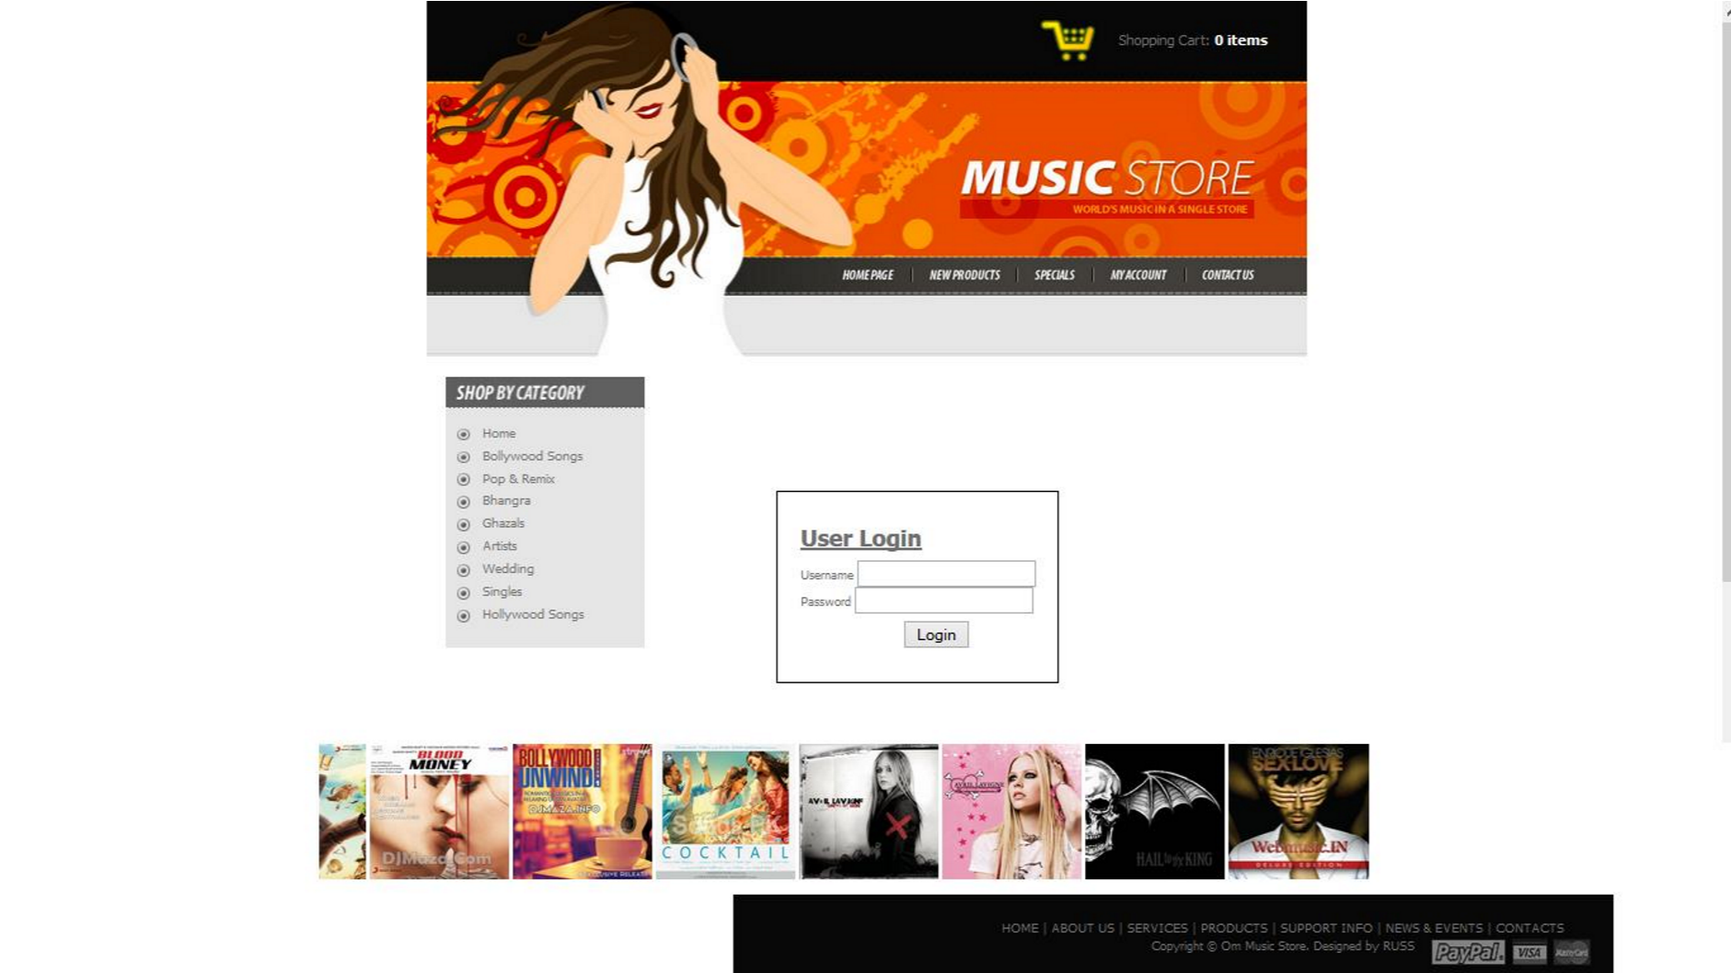

**USER REGISTRATION:-**

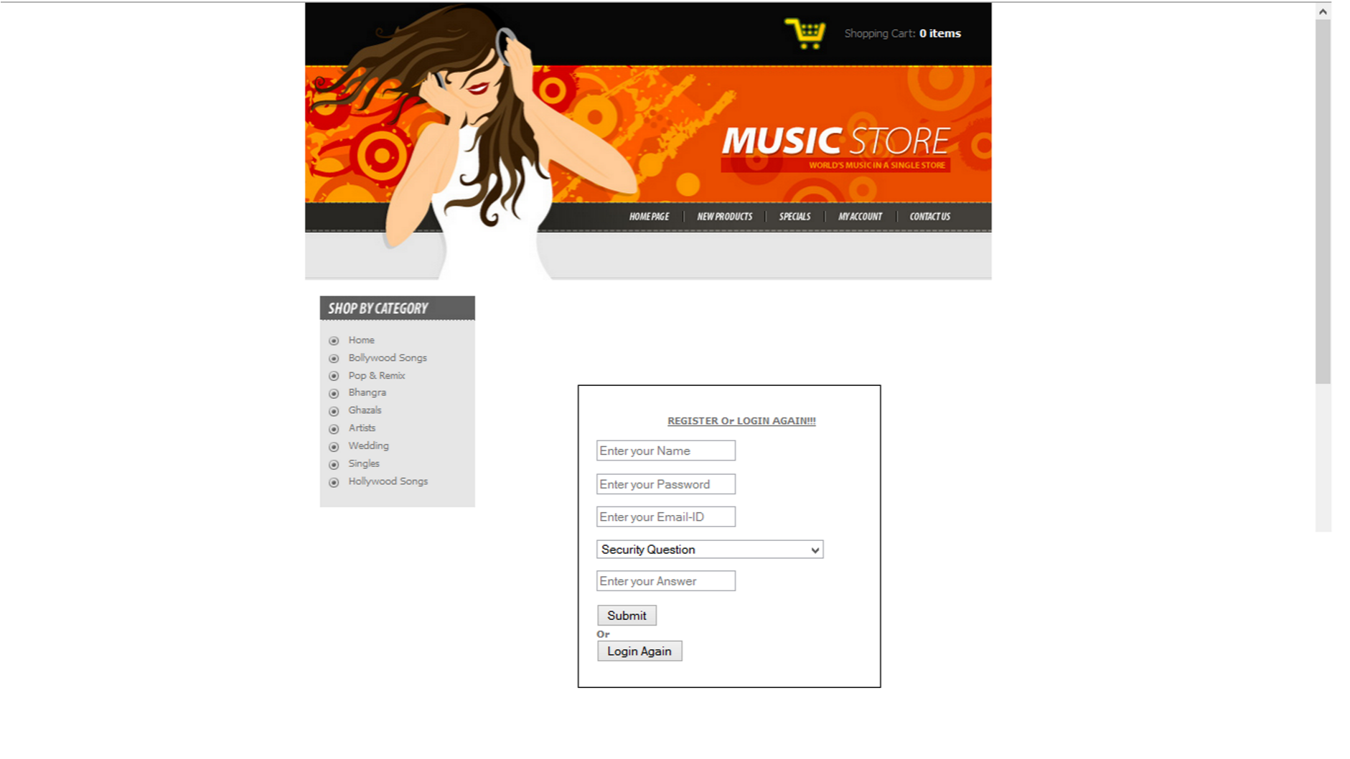

**ADMIN LOGIN :-**

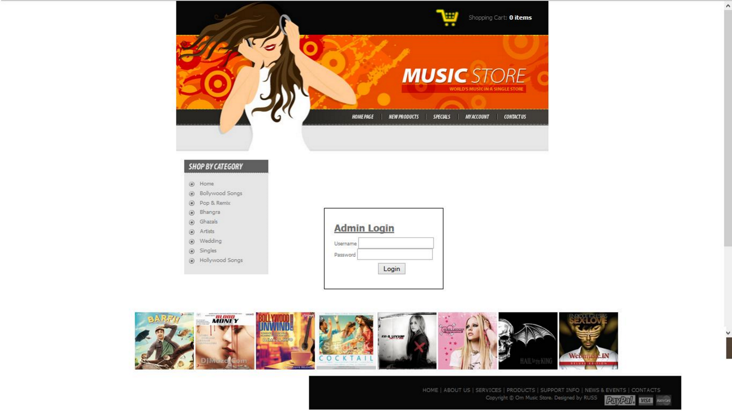

**SEARCH SONGS:-**

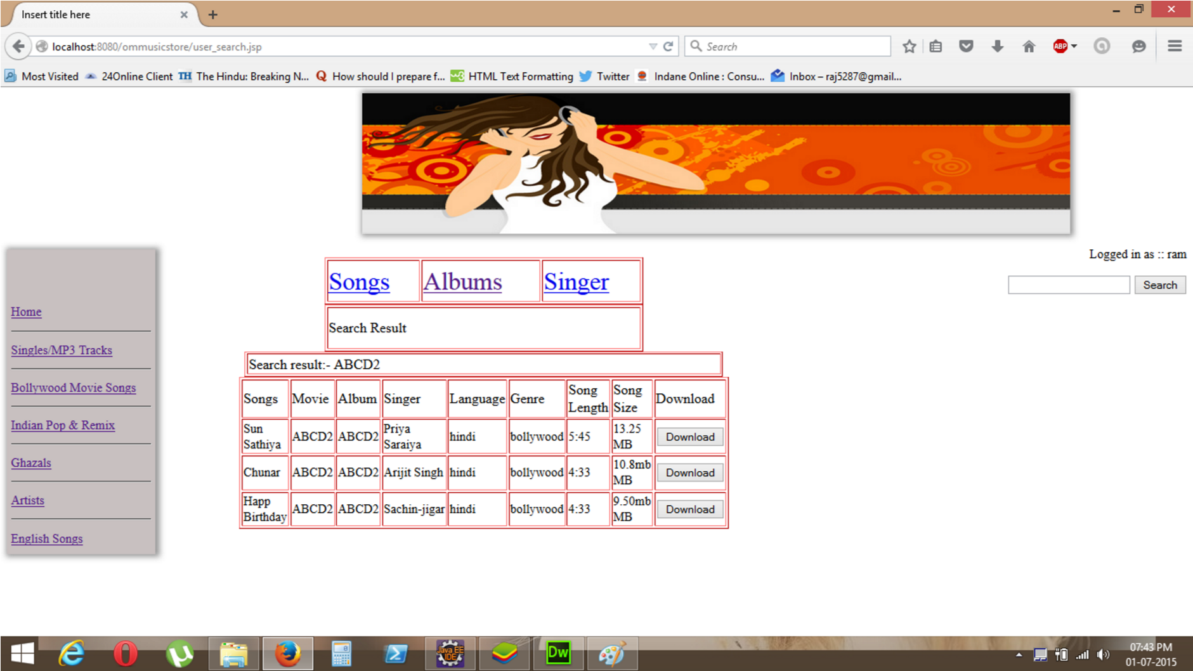

**DELETE SONGS:-**

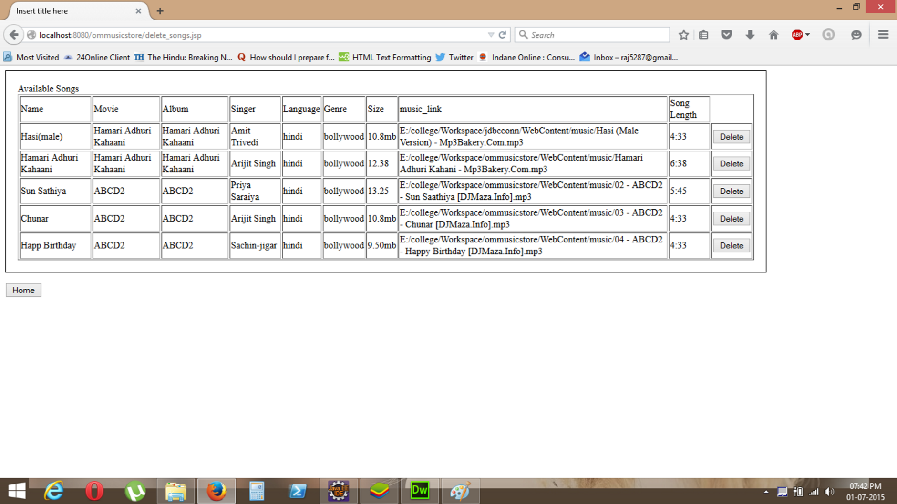

**VIEW SONGS:-**

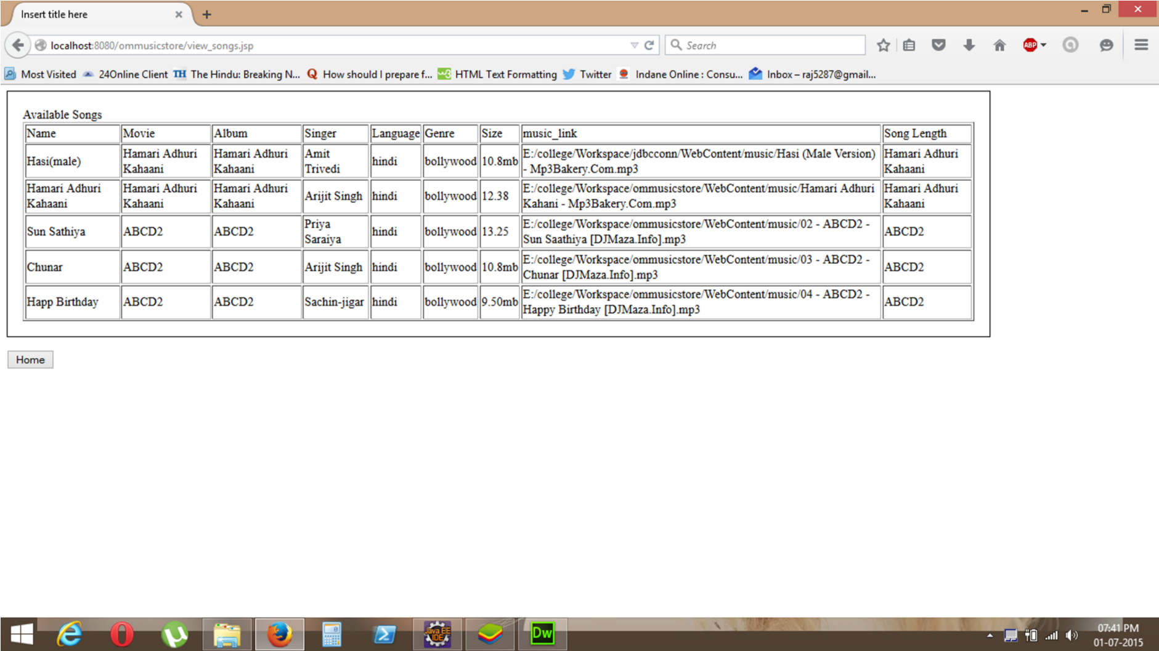

**DOWNLOAD SONGS:-**

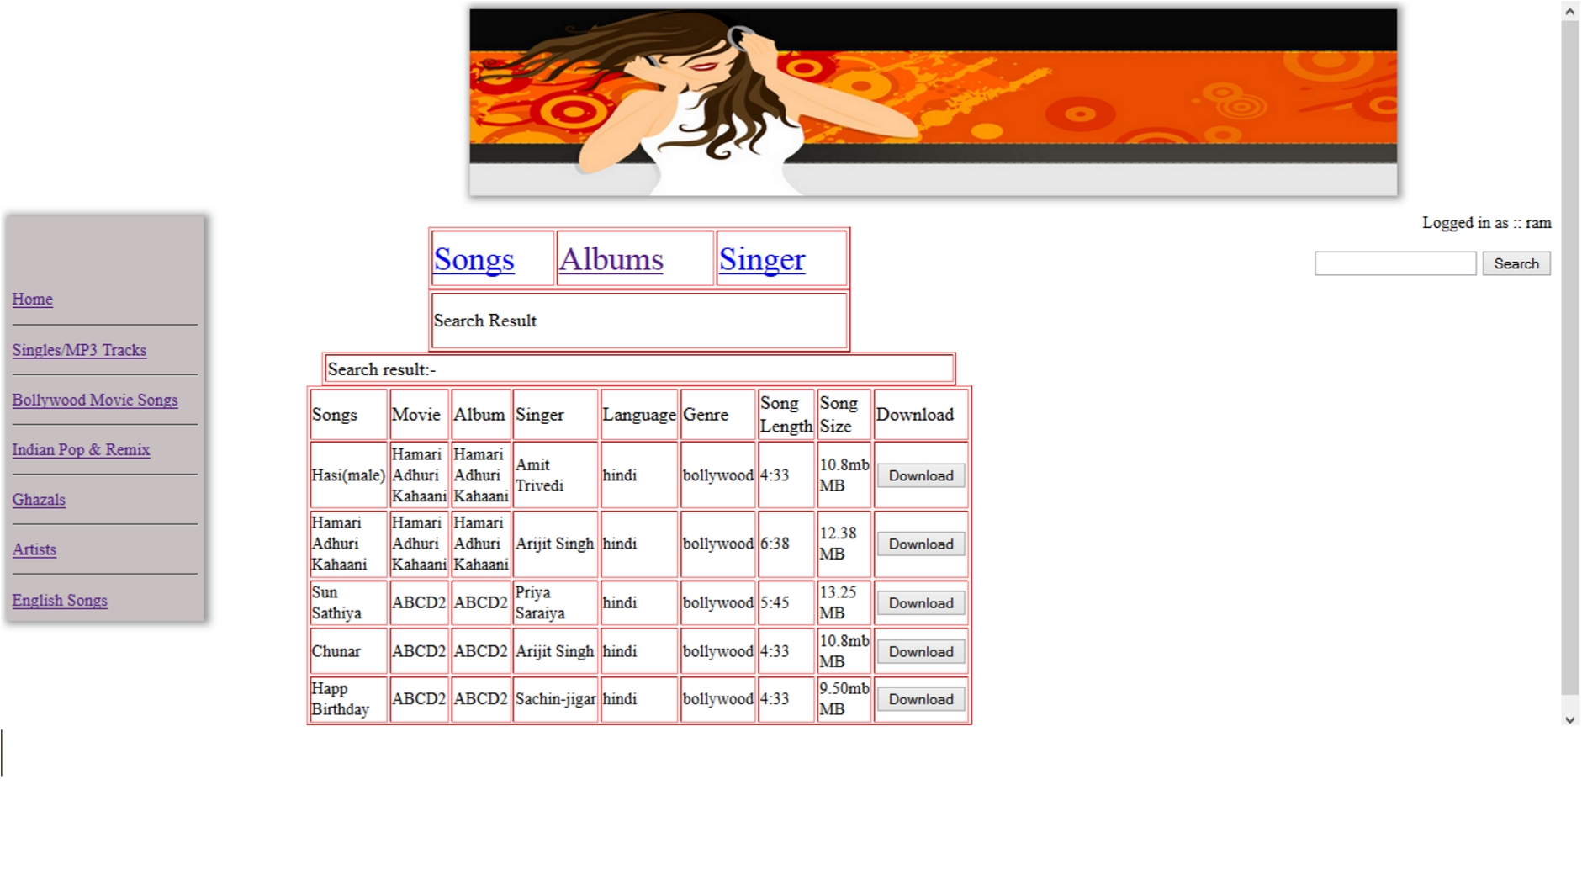

**CODE (Download)**

package user;

import java.io.File;

import java.io.FileInputStream;

import java.io.IOException;

import java.io.OutputStream;

import javax.servlet.ServletContext;

import javax.servlet.ServletException;

import javax.servlet.http.HttpServlet;

import javax.servlet.http.HttpServletRequest;

import javax.servlet.http.HttpServletResponse;

public class DownloadFile extends HttpServlet {

protected void doGet(HttpServletRequest request,

HttpServletResponse response) throws ServletException, IOException {

// reads input file from an absolute path

String filePath=request.getParameter("h1");

//out.println(det);

File downloadFile = new File(filePath);

FileInputStream inStream = new FileInputStream(downloadFile);

// if you want to use a relative path to context root:

String relativePath = getServletContext().getRealPath("");

System.out.println("relativePath = " + relativePath);

// obtains ServletContext

ServletContext context = getServletContext();

// gets MIME type of the file

String mimeType = context.getMimeType(filePath);

if (mimeType == null) {

// set to binary type if MIME mapping not found

mimeType = "application/octet-stream";

}

System.out.println("MIME type: " + mimeType);

// modifies response

response.setContentType(mimeType);

response.setContentLength((int) downloadFile.length());

// forces download

String headerKey = "Content-Disposition";

String headerValue = String.format("attachment; filename=\"%s\"", downloadFile.getName());

response.setHeader(headerKey, headerValue);

// obtains response's output stream

OutputStream outStream = response.getOutputStream();

byte[] buffer = new byte[4096];

int bytesRead = -1;

while ((bytesRead = inStream.read(buffer)) != -1) {

outStream.write(buffer, 0, bytesRead);

}

inStream.close();

outStream.close();

}

}

**UPLOAD SONGS:-**

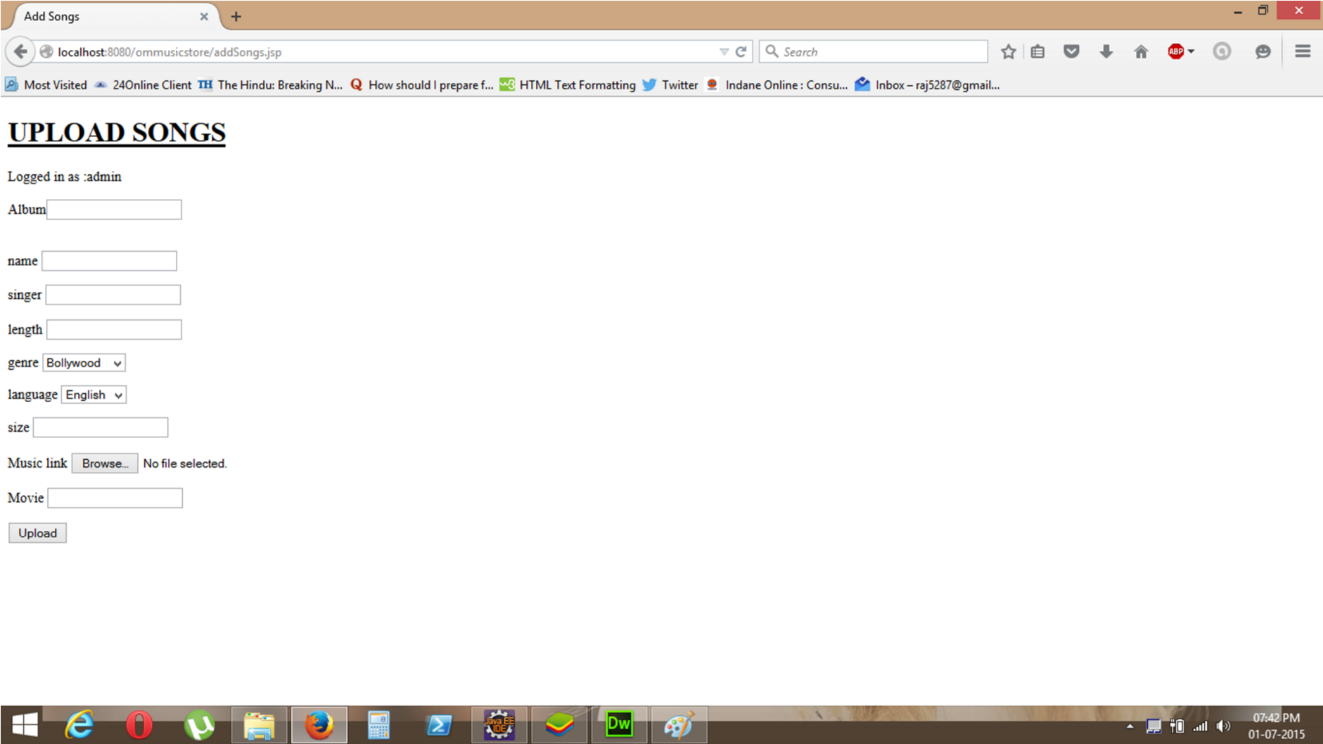

**CODE (Upload)**

package user;

import java.io.File;

import java.io.IOException;

import java.io.PrintWriter;

import java.util.*;

import javax.servlet.ServletException;

import javax.servlet.annotation.WebServlet;

import javax.servlet.http.HttpServlet;

import javax.servlet.http.HttpServletRequest;

import javax.servlet.http.HttpServletResponse;

import org.apache.commons.fileupload.FileItem;

import org.apache.commons.fileupload.disk.DiskFileItemFactory;

import org.apache.commons.fileupload.servlet.ServletFileUpload;

import java.sql.*;

@WebServlet("/UploadFile")

public class FileUploadHandler extends HttpServlet {

private static final long serialVersionUID = 1L;

private final String UPLOAD_DIRECTORY1= "E:/college/Workspace/ommusicstore/WebContent/music";

//private final String UPLOAD_DIRECTORY= "G:/Workspace/music library/WebContent/image_link/";

@Override

protected void doPost(HttpServletRequest request, HttpServletResponse response)

throws ServletException, IOException{

response.setContentType("text/html");

PrintWriter out = response.getWriter();

String name1=null;

String album1=null;

String song_name1=null;

String singer1=null;

String length1=null;

String genre1=null;

String language1=null;

String song_size1=null;

String song_link1=null;

String movie1=null;

//process only if its multipart content

if(ServletFileUpload.isMultipartContent(request)){

try {

List<FileItem> multiparts = new ServletFileUpload(

new DiskFileItemFactory()).parseRequest(request);

for(FileItem item : multiparts){

if(!item.isFormField()){

name1 = new File(item.getName()).getName();

item.write( new File(UPLOAD_DIRECTORY1 + File.separator + name1));

song_link1=UPLOAD_DIRECTORY1+"/"+name1;

}

else if (item.getFieldName().equals("album"))

{

String p1=item.getFieldName();

album1=item.getString();

}

else if (item.getFieldName().equals("name"))

{

String p2=item.getFieldName();

song_name1=item.getString();

}

else if (item.getFieldName().equals("singer"))

{

String p3=item.getFieldName();

singer1=item.getString();

}

else if (item.getFieldName().equals("length"))

{

String p4=item.getFieldName();

length1=item.getString();

}

else if (item.getFieldName().equals("genre"))

{

String p5=item.getFieldName();

genre1=item.getString();

}

else if (item.getFieldName().equals("language"))

{

String p6=item.getFieldName();

language1=item.getString();

}

else if (item.getFieldName().equals("song_size"))

{

String p7=item.getFieldName();

song_size1=item.getString();

}

else if (item.getFieldName().equals("movie"))

{

String p8=item.getFieldName();

movie1=item.getString();

}

}

//File uploaded successfully

request.setAttribute("message", "File Uploaded Successfully");

} catch (Exception ex) {

request.setAttribute("message", "File Upload Failed due to " + ex);

}

}else{

request.setAttribute("message",

"Sorry this Servlet only handles file upload request");

}

System.out.println("Details is"+album1);

Connection conn= null;

connect1 c=new connect1();

try{

//fpath=new String(UPLOAD_DIRECTORY);

//fpath=fpath.concat( File.separator).concat(name);

//System.out.println(fpath);

//System.out.println(name);

conn=c.connect();

System.out.println(" connection connected");

} catch(Exception e){System.out.println(" connection unconnected");}

try{

PreparedStatement pst=conn.prepareStatement("insert into music values(?,?,?,?,?,?,?,?,?)");

pst.setString(1,album1);

pst.setString(2,song_name1);

pst.setString(3,singer1);

pst.setString(4,length1);

pst.setString(5,genre1);

pst.setString(6,language1);

pst.setString(7,song_size1);

pst.setString(8,song_link1);

pst.setString(9,movie1);

System.out.println(album1);

pst.executeUpdate();

System.out.println("abc");

pst.close();

}catch(Exception e){System.out.println("errorrr");}

request.getRequestDispatcher("/result.jsp").forward(request, response);

}

}

**CODE (Style Sheet)**

/* CSS Document */

**body**{padding:*0px*; margin:*0px*; background:*#FFF*; color:*#6f6f6f*; font:*10px/14px* *Tahoma,* *sans-serif*;}

**div,** **p,** **ul,** **h2,** **h3,** **h4,** **img**{padding:*0px*; margin:*0px*;}

**ul**{list-style-type:*none*;}

*.clear* {clear: *both*; margin: *0px*}

/* HEADER */

*#header*{width:*775px*; height:*314px*; position:*relative*; background:*url(../images/b_top.jpg)* *0* *0* *no-repeat*; margin: *0* *auto*;}

*#logo*{width:*262px*; height:*55px*; position:*absolute*; top:*137px*; left:*470px* }

**ul***.menu*{height:*12px*; position:*absolute*; top:*236px*; left:*364px*;}

**ul***.menu* **li**{float:*left*}

*#header* **ul***.menu* **li***.home*{width:*50px*; height:*12px*; margin-right:*12px*}

*#header* **ul***.menu* **li***.home* **a**{width:*50px*; height:*12px*; display:*block*; background:*url(../images/btn_home.jpg)* *0* *0* *no-repeat*; text-indent:*-20000px*;}

*#header* **ul***.menu* **li***.home* **a***:hover*{width:*50px*; height:*12px*; background:*url(../images/btn_home_over.jpg)* *0* *0* *no-repeat*;}

*#header* **ul***.menu* **li***.new*{width:*67px*; height:*12px*; margin-right:*12px*}

*#header* **ul***.menu* **li***.new* **a**{width:*67px*; height:*12px*; display:*block*; background:*url(../images/btn_new.jpg)* *0* *0* *no-repeat*; text-indent:*-20000px*;}

*#header* **ul***.menu* **li***.new* **a***:hover*{width:*67px*; height:*12px*; background:*url(../images/btn_new_over.jpg)* *0* *0* *no-repeat*;}

*#header* **ul***.menu* **li***.specials*{width:*41px*; height:*12px*; margin-right:*12px*}

*#header* **ul***.menu* **li***.specials* **a**{width:*41px*; height:*12px*; display:*block*; background:*url(../images/btn_specials.jpg)* *0* *0* *no-repeat*; text-indent:*-20000px*;}

*#header* **ul***.menu* **li***.specials* **a***:hover*{width:*41px*; height:*12px*; background:*url(../images/btn_specials_over.jpg)* *0* *0* *no-repeat*;}

*#header* **ul***.menu* **li***.account*{width:*55px*; height:*12px*; margin-right:*12px*}

*#header* **ul***.menu* **li***.account* **a**{width:*55px*; height:*12px*; display:*block*; background:*url(../images/btn_account.jpg)* *0* *0* *no-repeat*; text-indent:*-20000px*;}

*#header* **ul***.menu* **li***.account* **a***:hover*{width:*55px*; height:*12px*; background:*url(../images/btn_account_over.jpg)* *0* *0* *no-repeat*;}

*#header* **ul***.menu* **li***.contact*{width:*52px*; height:*12px*; margin-right:*12px*}

*#header* **ul***.menu* **li***.contact* **a**{width:*52px*; height:*12px*; display:*block*; background:*url(../images/btn_contact.jpg)* *0* *0* *no-repeat*; text-indent:*-20000px*;}

*#header* **ul***.menu* **li***.contact* **a***:hover*{width:*52px*; height:*12px*; background:*url(../images/btn_contact_over.jpg)* *0* *0* *no-repeat*;}

*#header* **ul***.menu* **li***.line*{width:*2px*; height:*12px*; margin-right:*12px*; background:*url(../images/line_menu.jpg)* *0* *0* *no-repeat*;}

*#header* **ul***.lang* {height:*26px*; position:*absolute*; top:*277px*; left:*300px*;}

*#header* **ul***.lang* **li**{width:*40px* *float*:*left*;

padding-top: *2px*;

padding-right: *20px*;

position: *absolute*;

left: *51px*;

bottom: *px*;

top: *-3px*;

}

*#header* **ul***.lang* **li***.english*{width:*26px*; height:*18px*; margin-right:*13px*; padding:*0*}

*#header* **ul***.lang* **li***.english* **a**{width:*26px*; height:*18px*; display:*block*; background:*url(../images/btn_en.jpg)* *0* *0* *no-repeat*; text-indent:*-20000px*;}

*#header* **ul***.lang* **li***.german*{width:*26px*; height:*18px*; margin-right:*13px*; padding:*0*}

*#header* **ul***.lang* **li***.german* **a**{width:*26px*; height:*18px*; display:*block*; background:*url(../images/btn_ge.jpg)* *0* *0* *no-repeat*; text-indent:*-20000px*;}

*#header* **ul***.lang* **li***.spanish*{width:*26px*; height:*18px*; margin-right:*17px*; padding:*0*}

*#header* **ul***.lang* **li***.spanish* **a**{width:*26px*; height:*18px*; display:*block*; background:*url(../images/btn_sp.jpg)* *0* *0* *no-repeat*; text-indent:*-20000px*;}

*#header* **ul***.currency* {

height: *26px*;

position: *absolute*;

top: *277px*;

left: *491px*;

width: *253px*;

}

*#header* **ul***.currency* **li**{float:*left*;}

*#header* **ul***.currency* **li***.currency_headline* {font:*10px/12px* *Tahoma,* *Arial,* *Helvetica,* *sans-serif*; font-weight:*normal*; color:*#000*; padding-top:*4px*; padding-right:*8px*; float:*left*}

*#header* **ul***.currency* **li***.listmenu* **form**{float:*left*; width:*135px*; height:*18px*; margin: *0*;}

*#header* **ul***.currency* **li***.listmenu* **form** **select**{width:*135px*; height:*18px*; font:*10px/12px* *Tahoma,* *Arial,* *Helvetica,* *sans-serif*; color:*#000*;}

*#header* **ul***.currency* **li***.fbimage*{margin-left:*60px*;}

*#header* **ul***.currency* **li***.twimage*{margin-left:*10px*;}

*#header* **ul***.cart* {height:*50px*; position:*absolute*; top:*9px*; left:*538px*;}

*#header* **ul***.cart* **li**{height:*33px*; background:*url(../images/cart.jpg)* *0* *0* *no-repeat*; font:*12px/18px* *Tahoma,* *Arial,* *Helvetica,* *sans-serif*; font-weight:*bold*; color:*#FFF*; padding-top:*17px*; padding-left:*72px*;}

*#header* **ul***.cart* **li** **span**{color:*#6f6f6f*; font-weight:*normal*; }

/* CONTENT */

*#content*{width:*744px*; position:*relative*; margin: *0* *auto*; clear:*both*; padding: *18px* *15px* *0* *16px*;}

*#leftPan*{width:*176px*; position:*relative*; float:*left*; padding-right:*16px*;}

*#categories* {background:*#e6e6e6*; padding-bottom:*20px*;}

*#categories* **h2**{height:*29px*; background:*url(../images/h_category.jpg)* *0* *0* *no-repeat*; position:*relative*; padding-bottom:*10px*;}

*#categories* **ul**{padding-left:*10px*}

*#categories* **ul** **li** **a**{display:*block*; height:*20px*; background:*url(../images/bullet.jpg)* *0* *6px* *no-repeat*; font:*11px/20px* *Tahoma,* *Arial,* *Helvetica,* *sans-serif*; color:*#777777*; font-weight:*normal*; text-decoration:*none*; padding:*0* *0* *0* *23px*;}

*#categories* **ul** **li** **a***:hover*{text-decoration:*underline*; color:*#000*;}

*#middlePan*{width:*px*; position:*relative*; float:*left*; padding-right:*26px*;}

*.prod*{width:*500px*; height:*126px*; margin-bottom:*28px*; position:*relative*; clear:*both*;}

*.prodlast*{width:*500px*; height:*126px*; position:*relative*; clear:*both*;}

*.prodimg*{width:*119px*; margin: *2px* *19px* *0* *0*; float:*left*; position:*relative*;}

*.txt* **p** {width:*211px*; float:*left*; padding-top:*5px*; position:*relative*; padding-bottom:*20px*;}

*.txt* **p** **span**{font:*12px/14px* *Tahoma,* *Arial,* *Helvetica,* *sans-serif*; color:*#000*; font-weight:*bold*; text-decoration:*none*;}

*.txt* **p** **a**{font:*12px/14px* *Tahoma,* *Arial,* *Helvetica,* *sans-serif*; color:*#000*; font-weight:*bold*; text-decoration:*none*;}

*.txt* **p** **a***:hover*{text-decoration:*underline*;}

*.txt* **p** **a***.info*{font:*10px/12px* *Tahoma,* *Arial,* *Helvetica,* *sans-serif*; color:*#6f6f6f*; font-weight:*normal*; text-decoration:*underline*;}

*.txt* **p** **a***.info:hover*{text-decoration:*none*;}

*.action*{width:*345px*; height:*40px*;float:*left*;}

*.action* **ul** **li**{float:*left*;}

*.action* **ul** **li***.details*{width:*78px*; height:*17px*; margin-right:*19px*;}

*.action* **ul** **li***.details* **a**{width:*78px*; height:*17px*; display:*block*; background:*url(../images/btn_details.jpg)* *0* *0* *no-repeat*; text-indent:*-20000px*;}

*.action* **ul** **li***.add*{width:*102px*; height:*17px*;}

*.action* **ul** **li***.add* **a**{width:*102px*; height:*17px*; display:*block*; background:*url(../images/btn_add.jpg)* *0* *0* *no-repeat*; text-indent:*-20000px*;}

*.price*{width:*88px*; position:*absolute*; top:*6px*; left:*260px*}

*.price* **p**{font:*12px/14px* *Tahoma,* *Arial,* *Helvetica,* *sans-serif*; color:*#ea4d00*; font-weight:*bold*; text-align:*right*}

*.imag*{width:*100px*; position:*absolute*; top:*6px*; left:*400px*}

*#rightPan*{width:*176px*; position:*relative*; float:*left*}

*#new* {background:*#e6e6e6*; margin-bottom:*10px*; position:*relative*; padding-bottom:*10px*}

*#new* **h2**{height:*29px*; background:*url(../images/h_category.jpg)* *0* *0* *no-repeat*; position:*relative*; padding-bottom:*10px*;}

*#new* **img**{margin: *0* *13px* *10px* *12px*; position:*relative*; float:*left*;}

*#new* **p**{width:*76px*; padding-right:*15px*; float:*left*; font:*10px/12px* *Tahoma,* *Arial,* *Helvetica,* *sans-serif*; color:*#6f6f6f*; font-weight:*normal*; text-decoration:*none*;}

*#new* **a**{font:*10px/12px* *Tahoma,* *Arial,* *Helvetica,* *sans-serif*; color:*#6f6f6f*; font-weight:*normal*; text-decoration:*underline*;}

*#new* **a***:hover*{text-decoration:*none*; color:*#000*;}

*#new* *#addprice* **ul**{padding-left:*12px*; clear:*both*; position:*relative*; width:*152px*;}

*#new* *#addprice* **ul** **li**{float:*left*;}

*#new* *#addprice* **ul** **li***.newadd* **a**{width:*102px*; display:*block*; height:*17px*; background:*url(../images/btn_add2.jpg)* *0* *0* *no-repeat*; text-indent:*-20000px*;}

*#new* *#addprice* **ul** **li***.newprice* **img**{width:*50px*; height:*17px*; margin:*0*}

*#log.but*{}

*.but* **p**{height:*40px*;}

*.but* **p** **input**{position:*relative*;top:*5px*; left:*90px*}

/* FOOTER */

*#footer*{width:*775px*; height:*71px*; background:*#080808*; position:*relative*; margin: *10px* *auto* *0* *auto*; clear:*both*;}

*#footer* **img**{

width: *141px*;

height: *23px*;

position: *absolute*;

top: *40px*;

left: *615px*

}

*#footer* **p**{font:*10px/16px* *Tahoma,* *Arial,* *Helvetica,* *sans-serif*; font-weight:*normal*; color:*#6f6f6f*; display:*block*; width:*552px*; margin: *0* *0* *0* *208px*; padding-top: *22px*; text-align:*center*;}

*#footer* **a**{font:*10px/16px* *Tahoma,* *Arial,* *Helvetica,* *sans-serif*; font-weight:*normal*; color:*#6f6f6f*; text-decoration:*none*;}

*#footer* **a***:hover*{color:*#000*; text-decoration:*none*; background:*#FFF*;}

**CODE (Connection)**

<%@ page language=*"java"* contentType=*"text/html; charset=ISO-8859-1"*

pageEncoding=*"ISO-8859-1"*%>

<!DOCTYPE html PUBLIC "-//W3C//DTD HTML 4.01 Transitional//EN" "http://www.w3.org/TR/html4/loose.dtd">

<html>

<head>

<meta http-equiv=*"Content-Type"* content=*"text/html; charset=ISO-8859-1"*>

<title>Insert title here</title>

</head>

<body>

<%@ page import=*"java.sql.*"* %>

<%! Connection conn=**null**;%>

<%

**try**{

Class.forName("oracle.jdbc.driver.OracleDriver");

conn=DriverManager.getConnection("jdbc:oracle:thin:localhost:1521:orcl","scott","tiger");

System.out.print("driver 2 found");

}

**catch**(Exception e)

{

System.out.print("driver 2 not found");

}%>

</body>

</html>

**LIMITATIONS AND FUTURE SCOPE**

**OF THE PROJECT**

Although, the approach of this project is small, we have tried to have minimal limitations and also make it bug and error free.

The limitations possible with this project may be:

* Everyone can access the site without creating any account in the site.
* Only logged in members can download music.
* The website can easily get affected by virus because it is connected with Internet.
* User can only get the music as per order. As a user, there is no any facility of song transfer to someone whom user wants to dedicate the song.

**FUTURE SCOPE OF STUDY:-**

Scope of the project is very broad in terms of other manually taking exams. This project will have a very bright future if the following can be incorporated:

Few of them are:-

* There was a lot of thinking’s to increment the project, but for lack of time, many of them are still undone.
* There is a lot of scope to develop this project in future according to the requirements of particular interested people.

**CONCLUSION**

* ‘Online Music Gallery’ is a website for all type of people who

are actually the needed one. Anyone can search music from this website and they can be entertained through it, by creating their profiles. Otherwise anyone can see the website details, and listen songs, but can’t download.

* Hence we have developed the website ‘Online Music Gallery to fulfilling these demands of music for the needed one. Within a minute, any user can get details of the required song and download very fast.

**BIBLIOGRAPHY**

During the development of the project, we have used many resources and for that we are grateful to all the people concerned.

Given below are the names of some, which we have used during development and Documentation of the project.

[**“Head First Java”**](http://www.goodreads.com/book/show/231262.Head_First_Java) **by Kathy Sierra**

Useful sites for this project are as follows:

* www.w3school.com
* www.stackoverflow.com
* www.google.com

